MARCH NEWSLETTER
Greetings: Each year, Lent provides us all with the the time to prepare for the celebration of Easter. Lent is a time to reflect on how we are with God, our neighbours and with ourselves. We can make some changes in our attitudes, words, or actions, in order to be the best we can be. Lent is a time for doing more - more praying, more giving, and/or Lent is also when we give up something that distracts us from knowing God better. Giving alms (money, time, or possessions to help people in need) also happens during this time of Lent. On Easter Sunday, we will join in celebrating the Risen Lord.
During Lent, Holy Name Catholic School has chosen to learn more about Social Justice. As a school, many charities have had the school community’s support. This year, with a social justice focus, we will aim to work together for a global cause to make a difference. “Children Helping Children” is the title for the school’s project. With funds raised, Holy Name’s students will determine the best ways to help. Such items as seeds, goats, chickens, or a sewing machine may be chosen by the students to purchase for a community living in poverty.
God Bless, Mrs. McDonald

SHROVE TUES – Pancake Fundraiser:
On Tuesday, March 05/19 a Pancake Breakfast will take place from 8:00 AM – 9:30 AM with proceeds going toward our Lenten Project.
Caring and Safe Schools:
Pink Shirt Day: The Boys and Girls Clubs recognized Pink Shirt day on Wed. Feb. 27, 2019. This year’s theme was Choose Kindness. The Boys and Girls Clubs’ programs foster self-esteem, social engagement, academic success, inclusion, acceptance, respect for self and others and connection to community – all of which are key elements of bullying prevention. Students and staff were encouraged to wear pink in honour of this important cause.

Homework Club: The Literacy and Numeracy Secretariat is providing funding to elementary schools through the Ontario Focused Intervention Program (OFIP) Tutoring Initiative. As a result, the ALCDSB is providing direct support for elementary students who would benefit from some focused instructional support and practice. This tutoring supports Math and Language curriculum expectations that students are working on daily and assessed on during the EQAO assessments in May/June. Mrs. Mackler and Mr. Gaudet are sharing the instructor role for the primary group and Mr. Waller is the instructor for the junior group. The Homework Club began on Wed. Feb. 20, 2019 and will occur every Wednesday from 3:45 – 4:45 PM, ending on Wed. May 15, 2019. Positive mindset, perseverance, and sustained effort along with review of skills are the goals of this opportunity for the students attending.

Winter Fun!

Thanks to Madame Summers and students for organizing and participating in the Winter Carnival. Faith in Action is collaborating and supporting others.

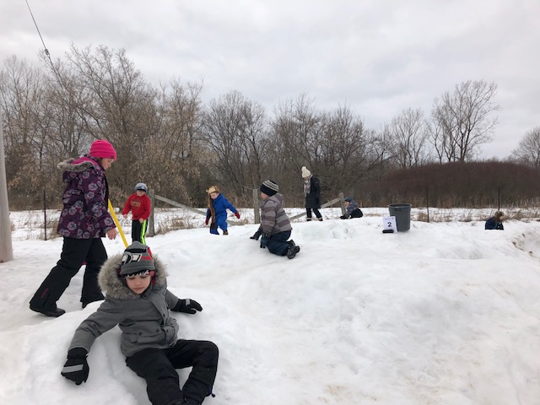

Congratulations For Community Success!

Evangelina Timpson and Anthony Kilpatrick both won first place at the Royal Canadian Legion Public Speaking Competition and have advanced to the next level of competition in Brockville on March 9, 2019! Good luck!
Colton Irwin, who recently won the Knights of Columbus Free Throw Shooting Competition for his age group, has advanced to the regional competition in Prescott over the March Break! Good luck!

FreshGrade: Kindergarten to Gr. 6 students and parents are communicating about learning using the FreshGrade App. 21st Century learning is evident!
ECO School Update: Letters, notices, and forms will continue to be posted on the school web page. Continue to follow the daily learning and special events of Holy Name with our school webpage and Twitter!
alcdsb_name
Full-day Kindergarten Registration – Registrations for the fall of 2019 are being accepted now. To register, the following documents are required: the child’s birth certificate, Catholic Baptismal certificate, and record of immunization. Registration packages can be picked up at the Main Office. Information about the full day Kindergarten program can be found at the Ministry of Education’s website at onatrio.ca/Kindergarten.
UPCOMING EVENTS:
Sports: Great successes by all teams who represented Holy Name well by demonstrating on-going perseverance, sportsmanship, and teamwork. The Sr. Boys participated in the Championship B Division lost by only one basket! Many thanks to the coaches: Mr. Gaudet (Jr. Boys), Mrs. Graham (Jr. Girls), Mr. Archer (Sr. Girls) and Mr. Waller (Sr. Boys).
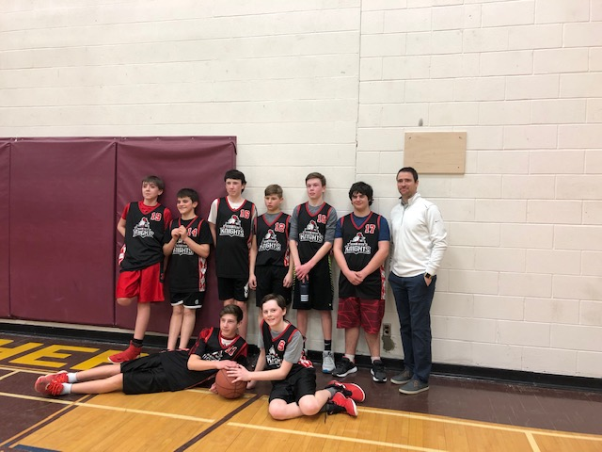

March Break: Mon. Mar. 11 – Friday Mar. 15, 2019 is the March Break and there is no school.
EARLY ON program will occur over the March Break on Tues. Mar. 12, 2019 from 9:30-10:30, in the school, over the March Break holiday.

Catholic School Council Update:
All parents are invited to attend the next School Council meeting scheduled for: Wed. April 24, 2019 at 6:30 PM in the Library Learning Commons.

